Decision Tree and Random Forest

Topic: Decision Tree and Random Forest

Hints:
- Business Problem
  - What is the business objective?
  - Are there any constraints?

- Work on each feature of the dataset to create a data dictionary as displayed in the below image:
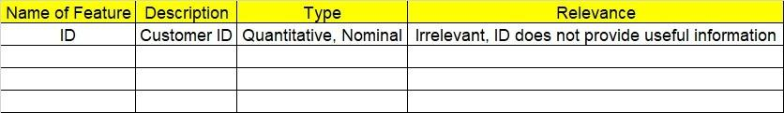

2.1 Make a table as shown above and provide information about the features such as its data type and its relevance to the model building. And if not relevant, provide reasons and a description of the feature.

- Data Pre-processing
3.1 Data Cleaning, Feature Engineering, etc.

- Exploratory Data Analysis (EDA):
  - Summary.
  - Univariate analysis.
  - Bivariate analysis.

- Model Building
  - Build the model on the scaled data (try multiple options).
  - Perform Decision Tree and Random Forest on the given datasets.
  - Train and Test the data and perform cross validation techniques, compare accuracies, precision and recall and explain about them.
  - Briefly explain the model output in the documentation.

- Write about the benefits/impact of the solution - in what way does the business (client) benefit from the solution provided?

Problem Statements:

- A cloth manufacturing company is interested to know about the different attributes contributing to high sales. Build a decision tree & random forest model with Sales as target variable (first convert it into categorical variable).

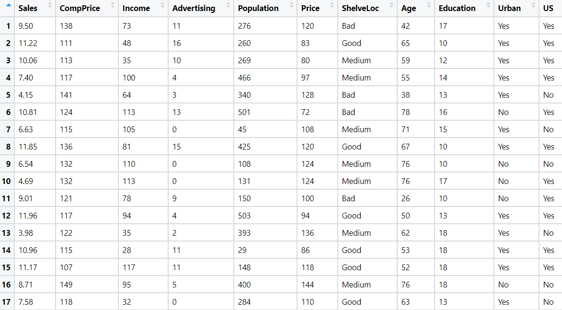
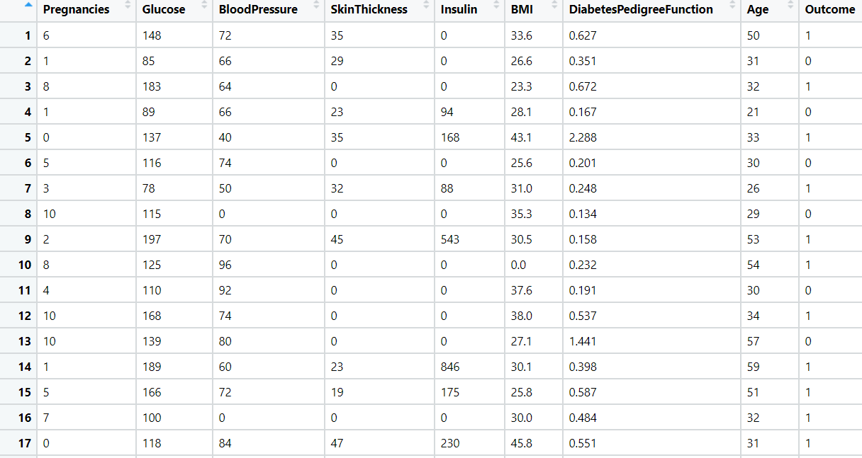
- Divide the diabetes data into train and test datasets and build a Random Forest and Decision Tree model with Outcome as the output variable.

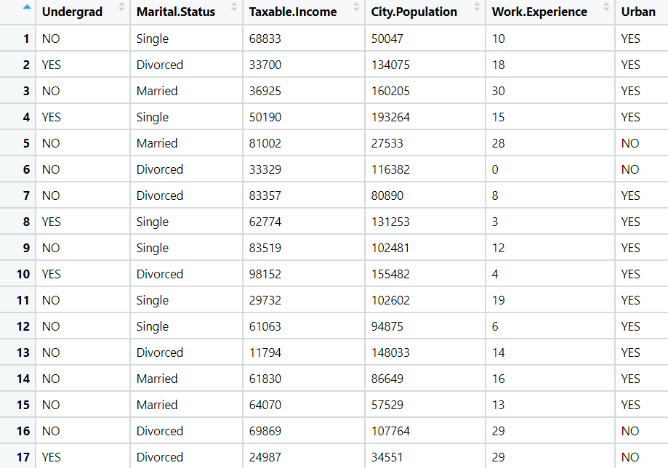
- Build a Decision Tree & Random Forest model on the fraud data. Treat those who have taxable_income <= 30000 as Risky and others as Good (discretize the taxable income column).

- In the recruitment domain, HR faces the challenge of predicting if the candidate is faking their salary or not. For example, a candidate claims to have 5 years of experience and earns 70,000 per month working as a regional manager. The candidate expects more money than his previous CTC. We need a way to verify their claims (is 70,000 a month working as a regional manager with an experience of 5 years a genuine claim or does he/she make less than that?) Build a Decision Tree and Random Forest model with monthly income as the target variable.
